Association Rule Mining

Transactions in a Super Market (D)

1.   
2. 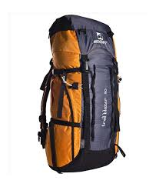  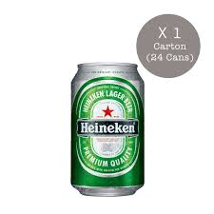 
3.   
4.  c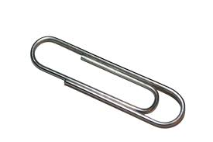 
5.   
6.   
7.  
8.   
9.  
10.    

A-Priori Algorithm

1. Scan the transactions (D)

|  |  |
| --- | --- |
| **Items** | **Support** |
|  | 2 |
|  | 4 |
|  | 3 |
|  | 2 |
|  | 4 |
|  | 4 |
|  | 1 |
|  | 1 |
|  | 1 |
|  | 2 |
|  | 3 |
|  | 2 |
|  | 2 |

1. Find the minimum support (Omit the transactions happened only once)

i.e , remove

   

|  |  |
| --- | --- |
| **Items** | **Support** |
|  | 2 |
|  | 4 |
|  | 3 |
|  | 2 |
|  | 4 |
|  | 4 |
|  | 2 |
|  | 3 |
|  | 2 |

1. Item sets (Combination of 2) and count the same

  🡪 1

 🡪 1

 🡪 0

  🡪 0

 🡪 1

 🡪 0

 🡪 0

  🡪 0

  🡪 1

  🡪 1

  🡪 2

  🡪 2

  🡪 0

  🡪 0

  🡪 0

  🡪 0

  🡪 0

  🡪 0

 🡪 0

  🡪 1

  🡪 1

  🡪 0

  🡪 2

  🡪 2

  🡪 0

  🡪 0

  🡪 0

  🡪 3

 🡪 0

  🡪 0

  🡪 0

  🡪 0

  🡪 0

  🡪 0

  🡪 2

  🡪 1

  🡪 2

So we have these finalists

  🡪 2

  🡪 2

  🡪 2

  🡪 2

  🡪 3

  🡪 2

  🡪 2

1. Repeat Process 3 (Combination of 3 ) and count the same)

  🡪 1

🡪1

🡪0

  🡪 0

🡪1

 🡪 0

 🡪 0

🡪 2

🡪 0

 🡪 0

 🡪 0

 🡪 0

 🡪 0

 🡪 0

Only one combination survived the test

🡪 2

This is called A-Priori Algorithm